Adrien Protzel

1. S=Start symbol, P=Production rule
   1. V = {S, P}

S -> P1P1P1P

P -> 0P | 1P | λ

* 1. V = {S}

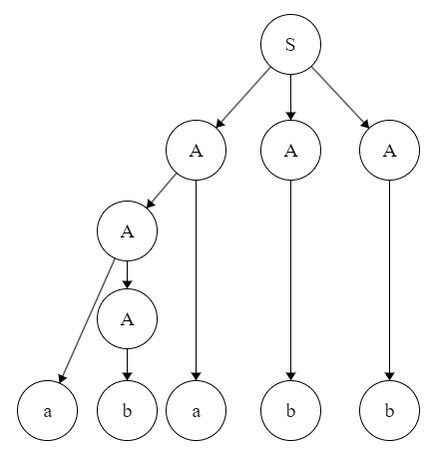S -> 0S0 | 1S1 | λ

* 1. V = {S, A, B, X, Y}

S -> AX | B

A -> aAb | λ

X -> cX | λ

B -> aBc | Y

Y -> bY | λ

1. 1. 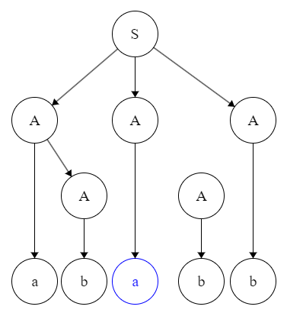S -> AAA

-> aAAA

-> abAA

-> abbA

-> abbaA

-> abbaAa

-> abbaba

* 1. w = ababb =>

S -> aAB

A -> aAB | b

B -> b

* 1. S -> AA

A -> aAb | λ

* 1. S -> SA | λ

A -> aAb | λ

1. Suppose we have L={$a^{b^{n}}:n≥0$}\*

S -> SA | λ

A -> aAb | λ

The A becomes a recursion statement that makes an unlimited sting of a’s and b’s. Since n={a,b} then n\* is all combinations of a and b then we can say that the language is closed under \* closure.